**Project Design Phase-I Solution Architecture**

|  |  |
| --- | --- |
| Date | 05 November 2022 |
| Team ID | PNT2022TMID08472 |
| Project Name | Project - IoT Based Safety Gadget for Child Safety Monitoring and Notification |
| Maximum Marks | 4 Marks |

**Solution Architecture:**

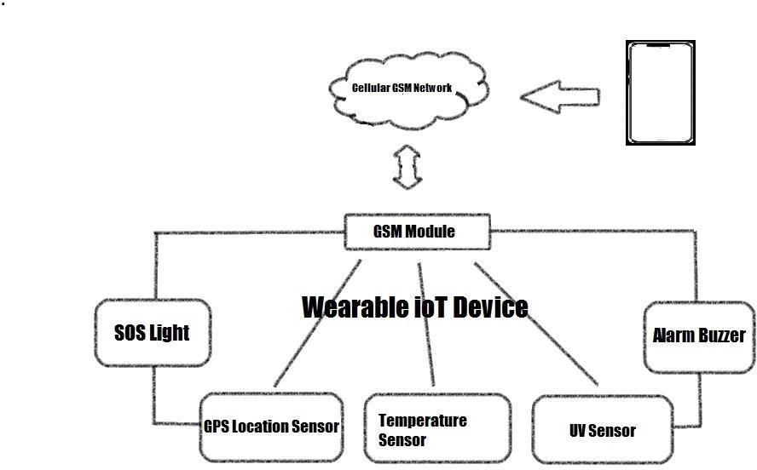

# Purpose of child monitoring device:

It makes parents to make monitor their child from their workplace. Basically childrens are not say about abusement or harrasment which they face in their life. Parents can be relax and calm by using this device.

# Device lifetime:

The device uses solar charging unit is proposed to overcome the limitation of battery life so that the device will be always charge up. When there is no sufficient solar energy then battery backup is also available This can be used for over long period of time.

# Function:

The device has IOT monitoring allows to monitor the child from anywhere with any portable devices. Ultrasonic sensor are used which sense when someone near child and alarm buzz will established SMS and dialing function is made to parents